Team 02

Version 1.0

Heritage College

Coding challenge system

User Documentation

Contents

2 Description of system 2

3 System users 3

4 main functionality 4

5 teacher workflow 6

5.1 create 7

5.1.1 Details 7

5.1.2 Function Data 8

5.1.3 Testing Suite 9

5.2 edit 13

5.3 delete 14

6 Student flow 16

6.1 Home page after login 16

6.2 Recent Challenges 17

6.3 Attempting a challenge 17

# Description of system

The Coding Challenge System is a teaching tool for Heritage College that allows students to sharpen their programming skills online in their language of choice through custom challenges made as a collective effort by teachers. These teachers have full control over what coding challenges they would like students to attempt, and what specific test cases need to be passed in order for them to be marked as complete. Currently, only Python is supported, but more languages will be supported in the future.

# System users

The users of the system are both Teachers and Students, primarily being the students who have access to created challenges made by the teachers. A teacher has access to the list of their own challenges, which they may modify as they please. Teachers have control of the visibility status for challenges and the full removal of one which will remove all data affiliated with that specific challenge. Students may view all challenges that are currently set as visible and may freely attempt a challenge any amount of times either in the same language or another.

# main functionality

The main functionality of CCS is to provide a learning environment for students to test their coding skills. They can login using their student credentials and view their recently attempted or completed challenges, as well as view all available challenges and select one they would like to do. When attempting a challenge and choosing to submit the current code, test cases are ran from which the teacher originally provided upon creating the specific challenge. Students are not limited to how many times they can attempt a challenge.

# teacher workflow

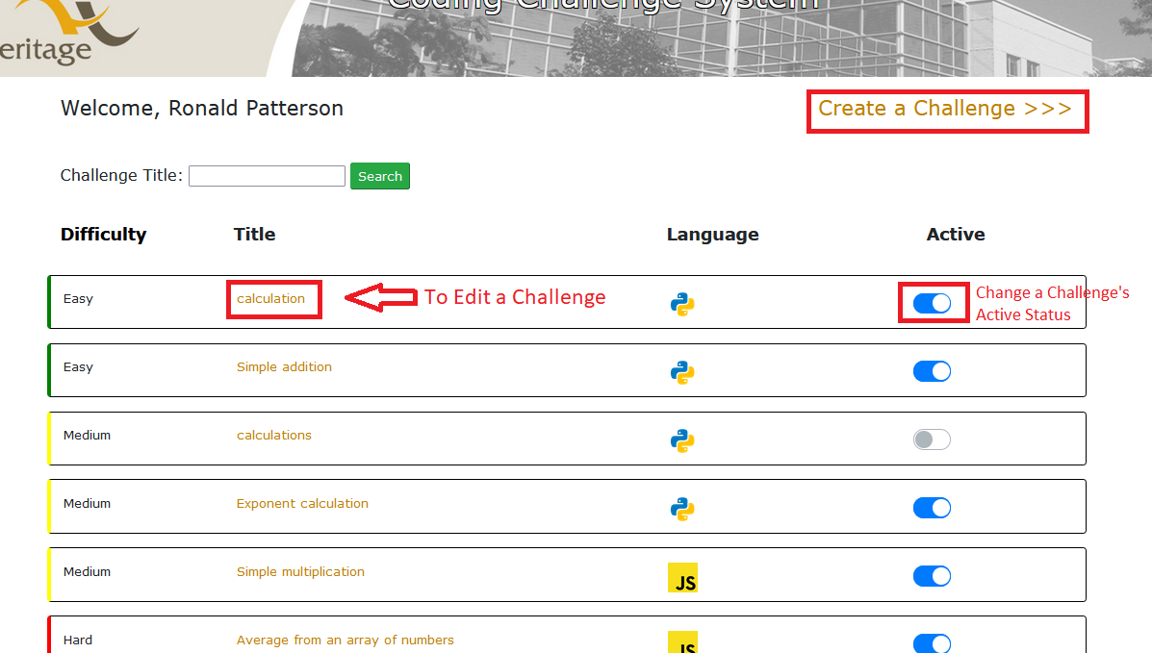

Figure 2. The Teacher is greeted with the homepage once they login

## create

### Details

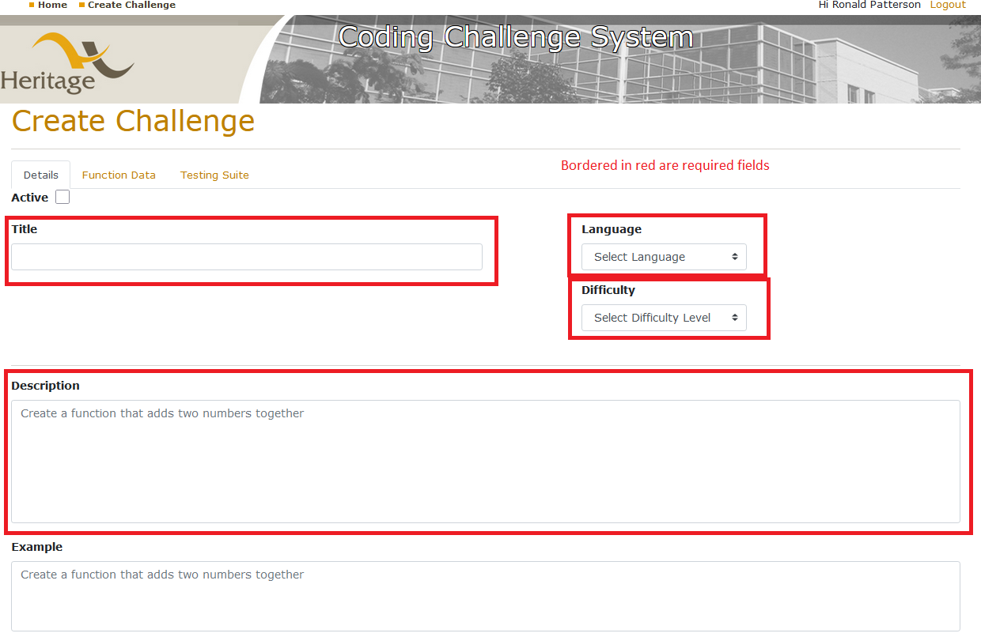

Figure 3. A Techer is greeted by the Details tab when they first Create a Challenge

### Function Data

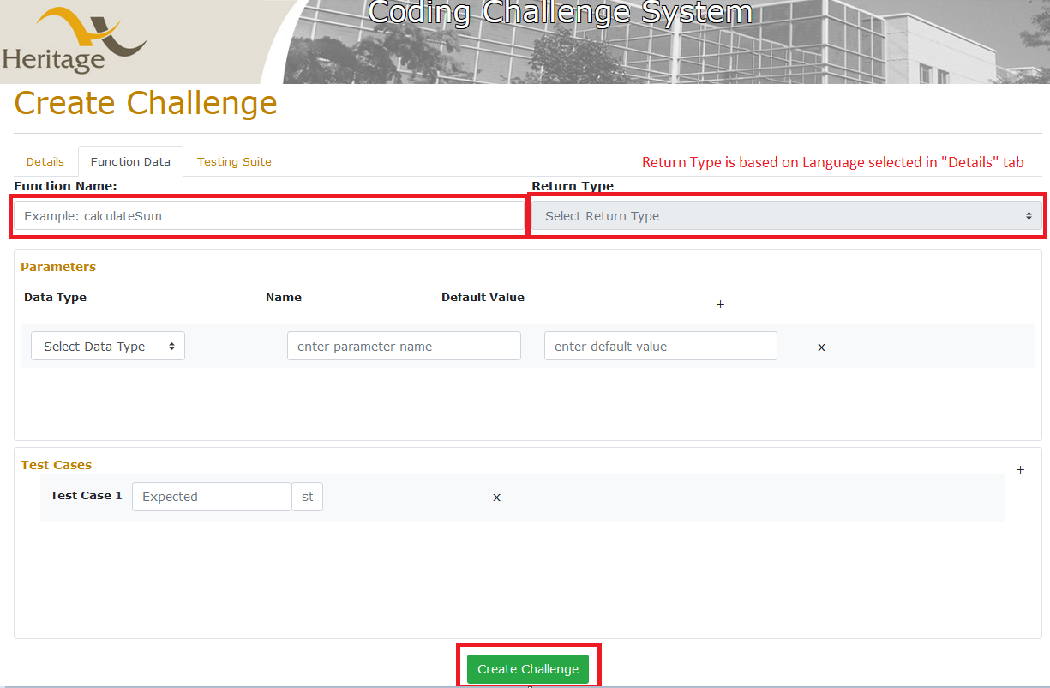

Figure 4. The function data tab contains any information relevant to the actual challenge function data. Once the fields are filled, a Challenge can be created

### Testing Suite

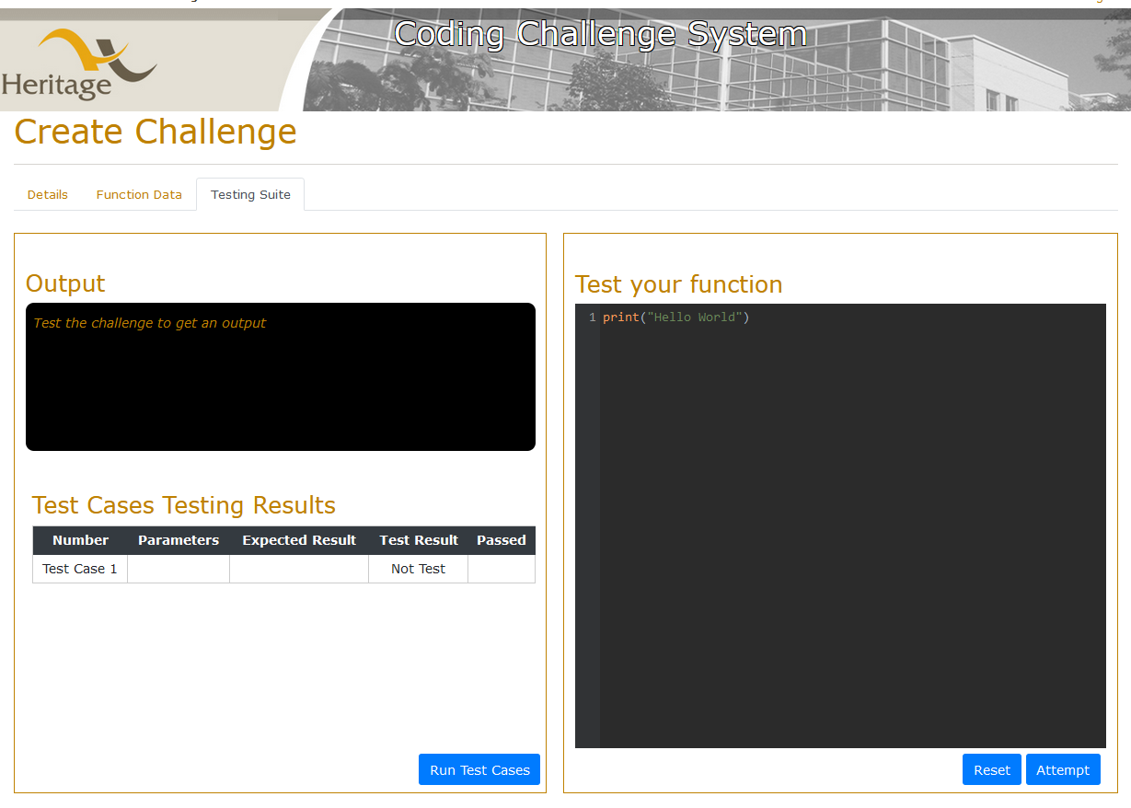

Figure 5. The testing suite allows the Teacher to test the test cases defined in the “Function Data” page. Clicking “Run Test Cases” will show whether the test case passed/faile.

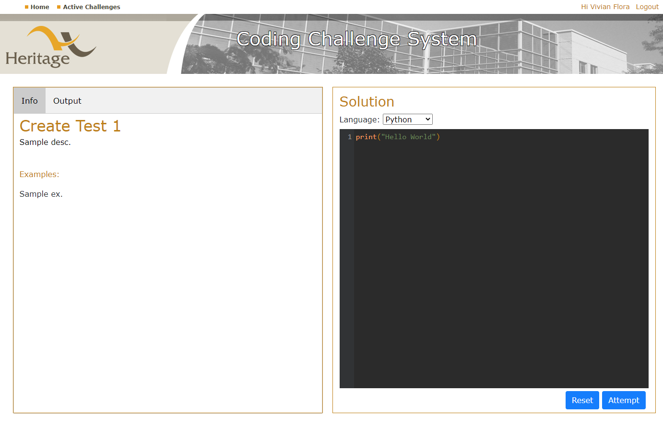

Figure 2. The student can solve the coding challenge from this menu

The teacher can create, edit and delete challenges from their interface, as well as set them as inactive or active from the view challenge menu. The teacher can also add details to the challenge such as an example and description to clarify things for the students.

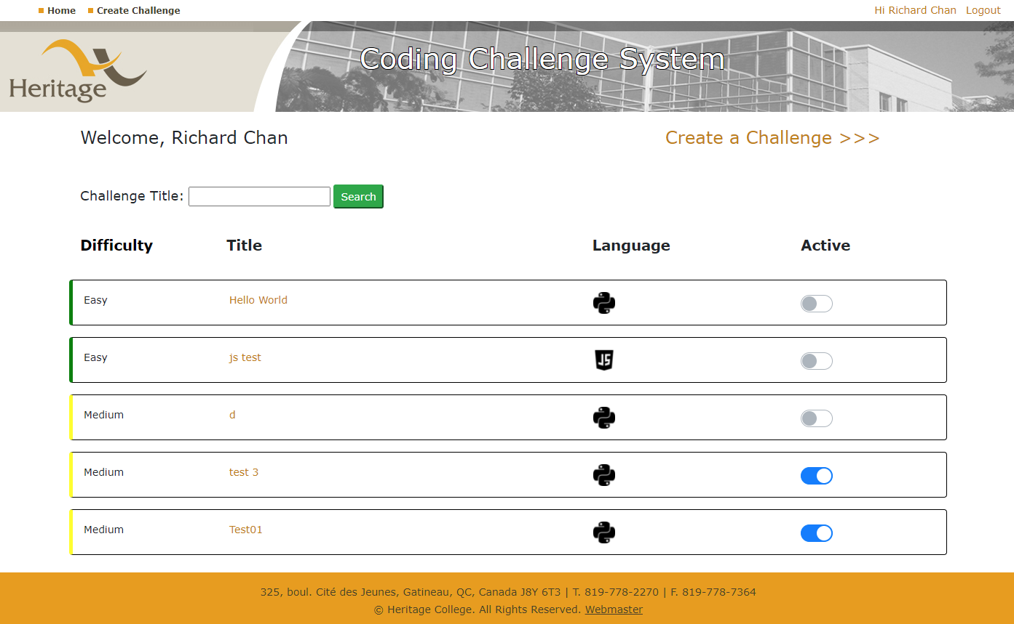

Figure 3. The teacher can see all their challenges and toggle their visibility to students via the active slider

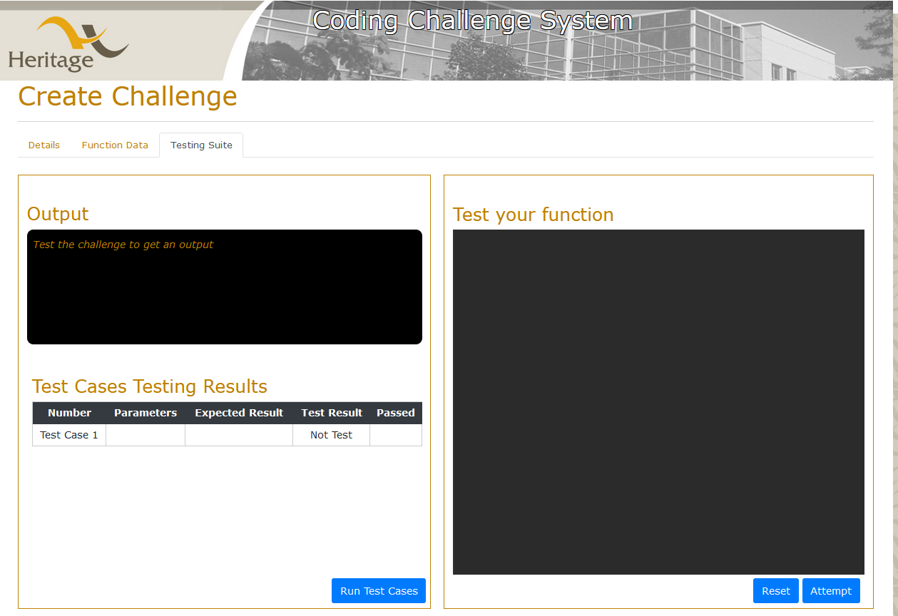

Figure 4. The teacher can create challenges and test cases for the students to test their answers against

## edit

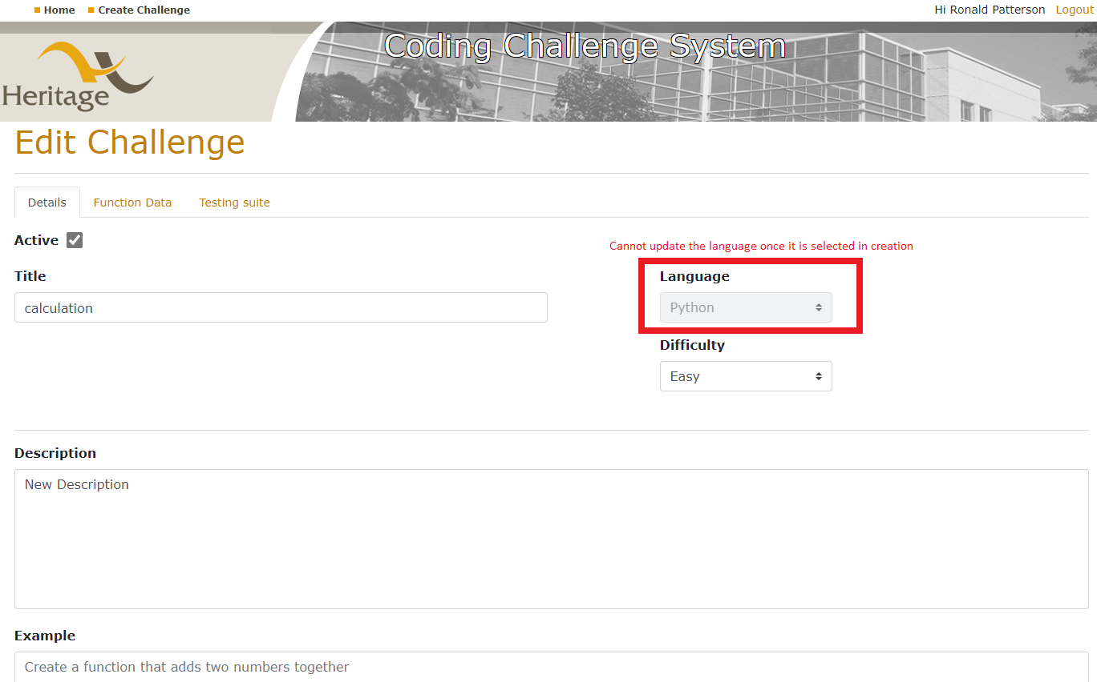

Figure 5. Everything can be updated in the Details tab except the Language which can only be selected when you are creating the challenge

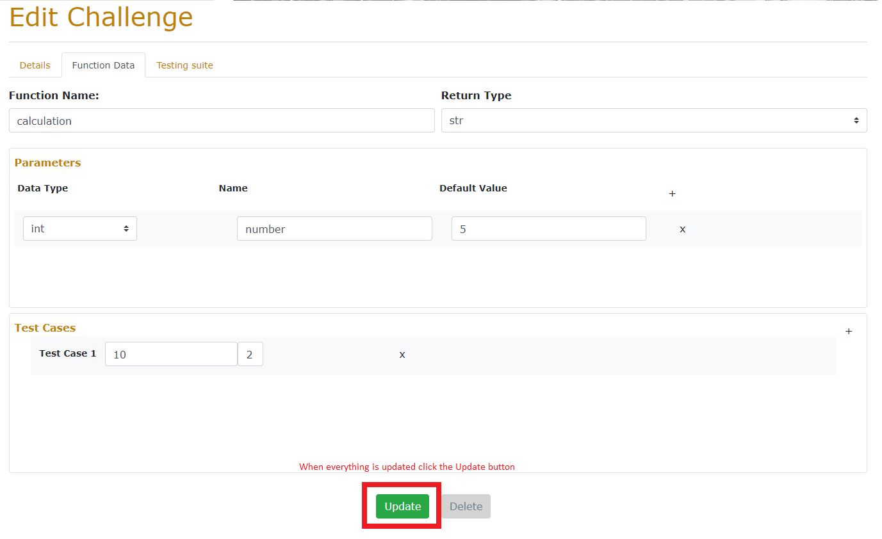

Figure 6 When everything is updated, click the update button to save your changes

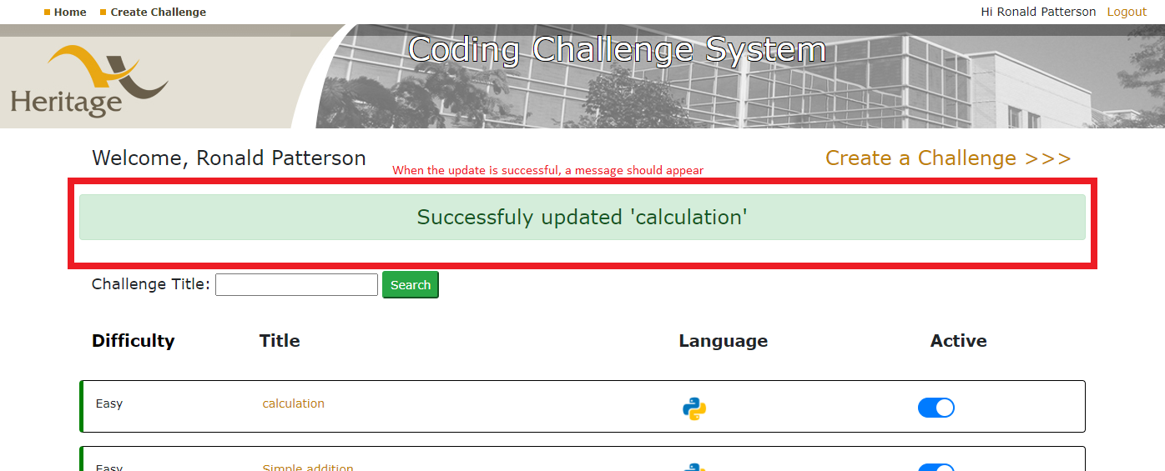

Figure 7 A successful update should result in a green success message. In the message, you should see the appropriate title of the challenge you updated

## delete

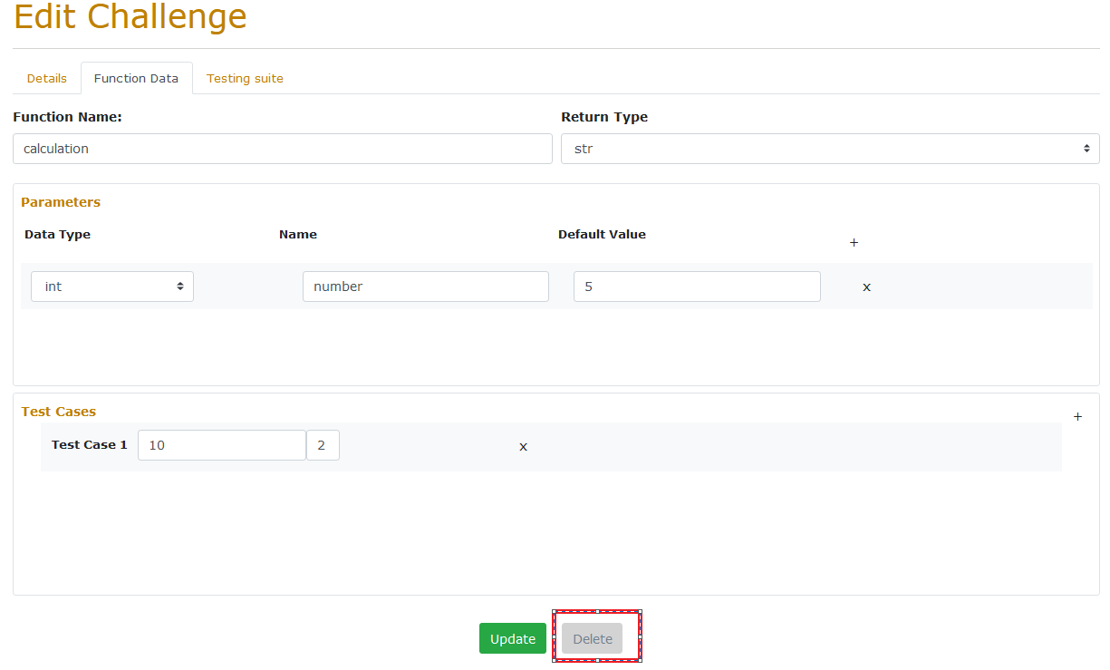

Figure 8. To delete a challenge, navigate to the Edit Challenge page under the Function Data tab

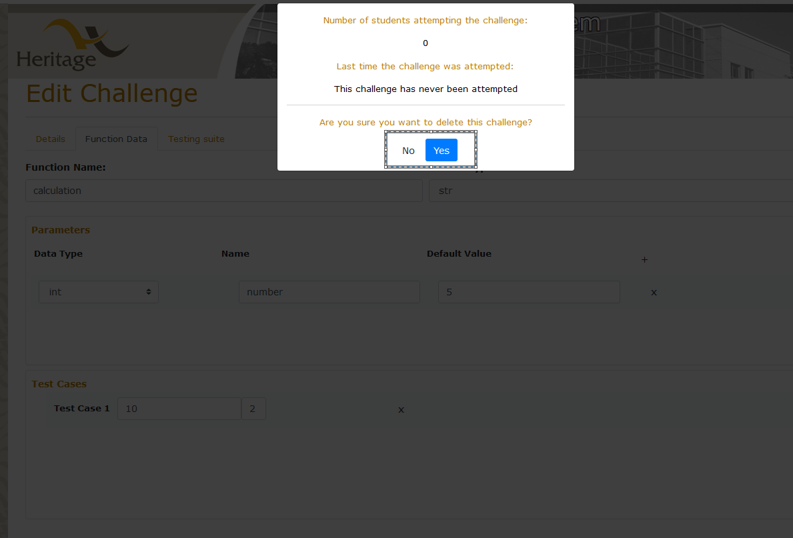

Figure 9. The popup will display if students are attempting the challenge and when it was last attempted. Clicking “No” or anywhere outside of the popup will make the popup disappear. A success or failure message will be displayed if the user clicks “yes” on the home page

# Student flow

## Home page after login

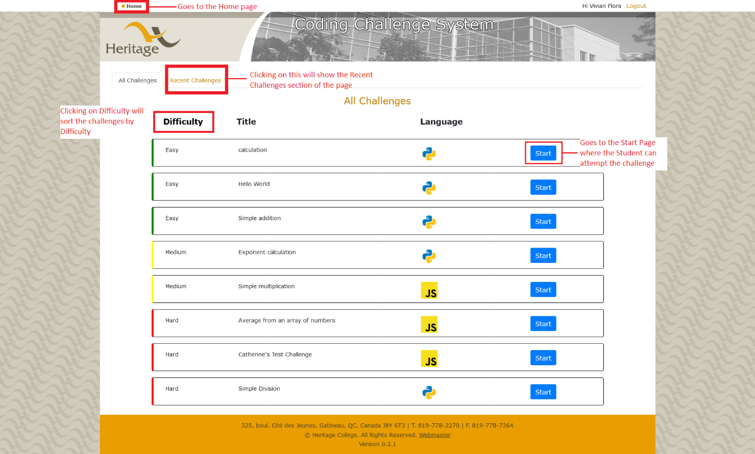

Figure 10. The student can start a new Challenge from this menu, from a selection of all the challenges. They can also see the recent challenges (refer to Figure 11.)

## Recent Challenges

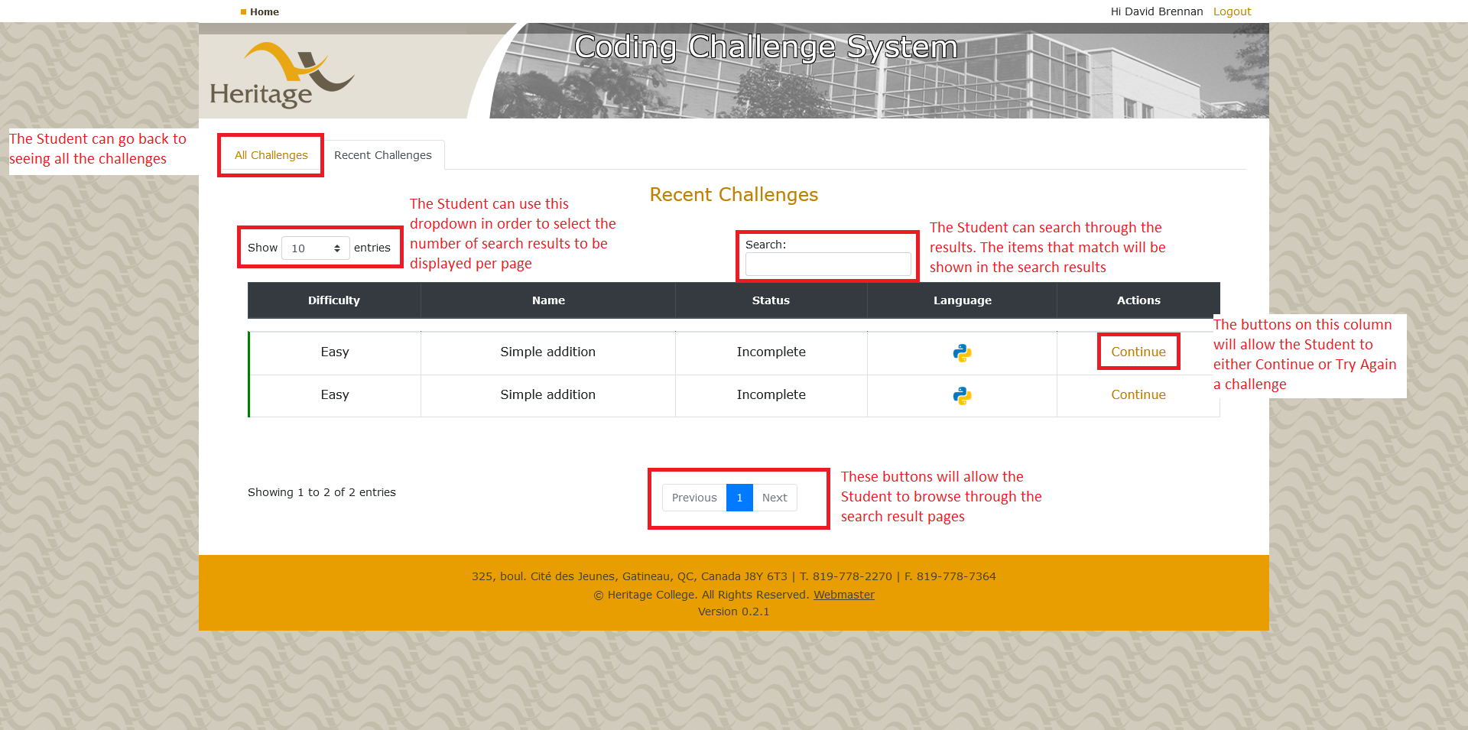

Figure 11. The student can see recent challenges they tried.

## Attempting a challenge

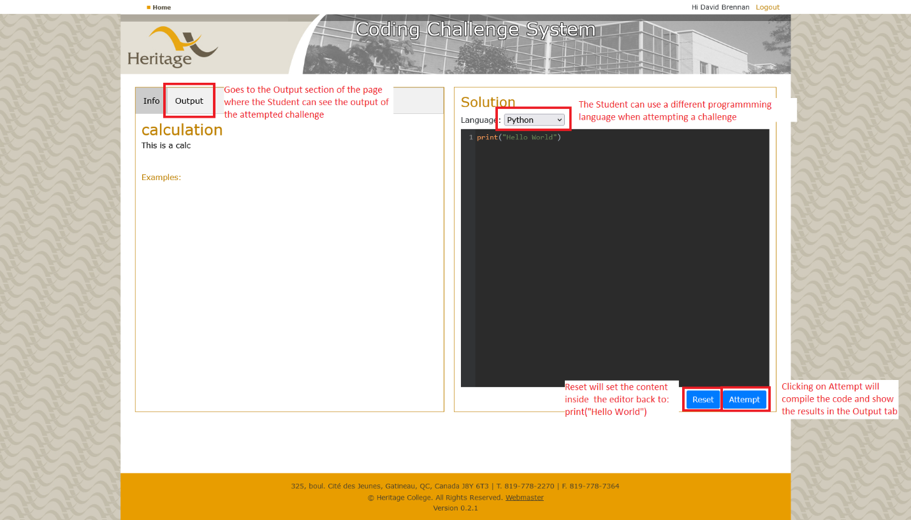

Figure 12. The student can solve the coding challenge from this menu (refer to Figure 4. to see how the output looks like).

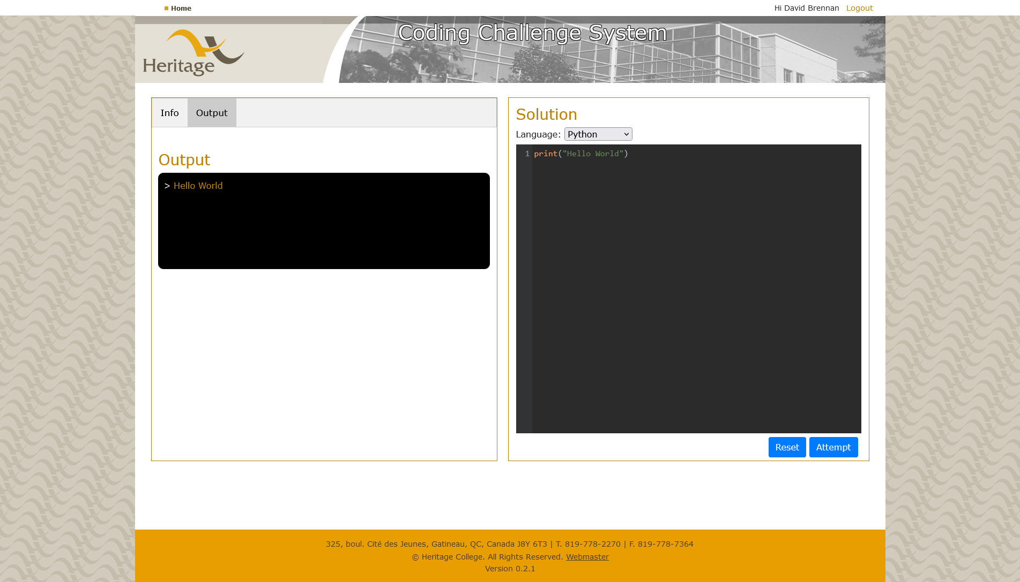

Figure 13. When clicking on the Attempt button, the left hand side of the screen will switch to the output tab.